**How to run** [**wikidataintegrator**](https://github.com/SuLab/WikidataIntegrator) **python script**

**Prerequisites**

* PyCharm IDE <https://www.jetbrains.com/pycharm/>
* Python (version 3.9) <https://www.python.org/downloads/>

1. Open PyCharm IDE.
2. 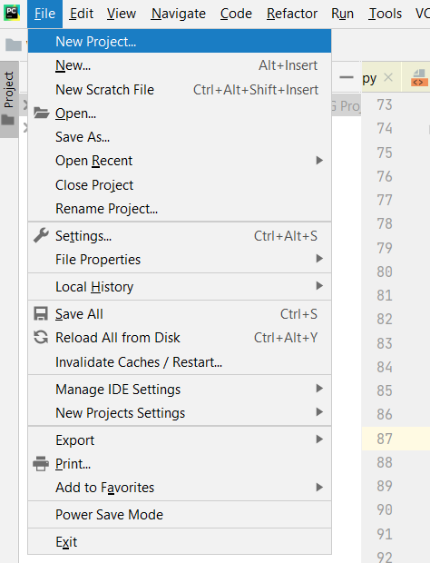Create a new project. **MainMenu -> File -> NewProject**
3. Fill the required fields in the Create Project window as follows and click on the create button.

**Note**: - “NIG_Project” is given as Project Name.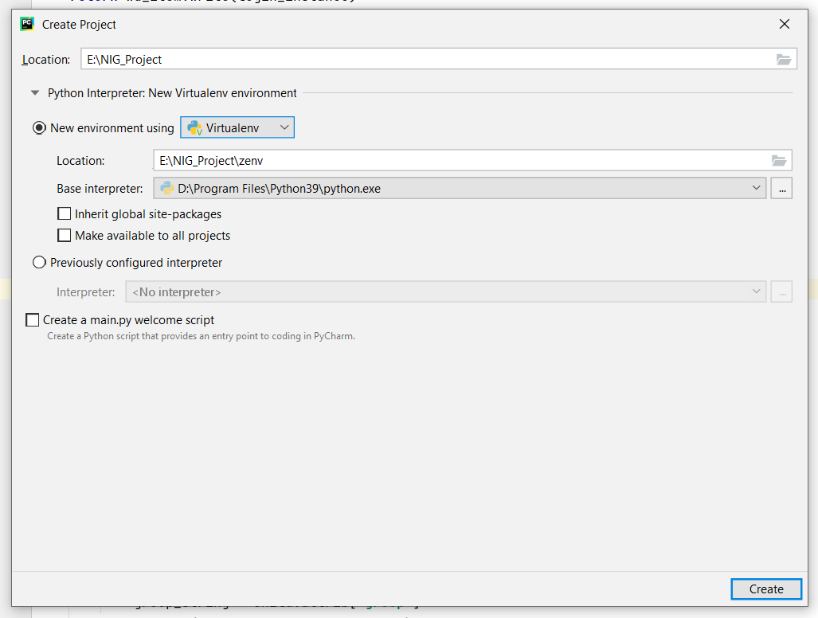

1. 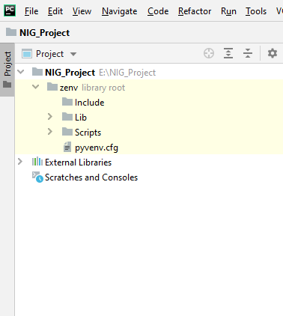NIG_Project structure can be seen in the Project window as following image.

1. 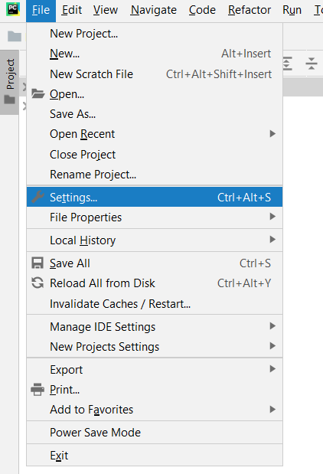Install “wikidataintegrator” to the project environment. **MainMenu -> File -> Settings**
2. 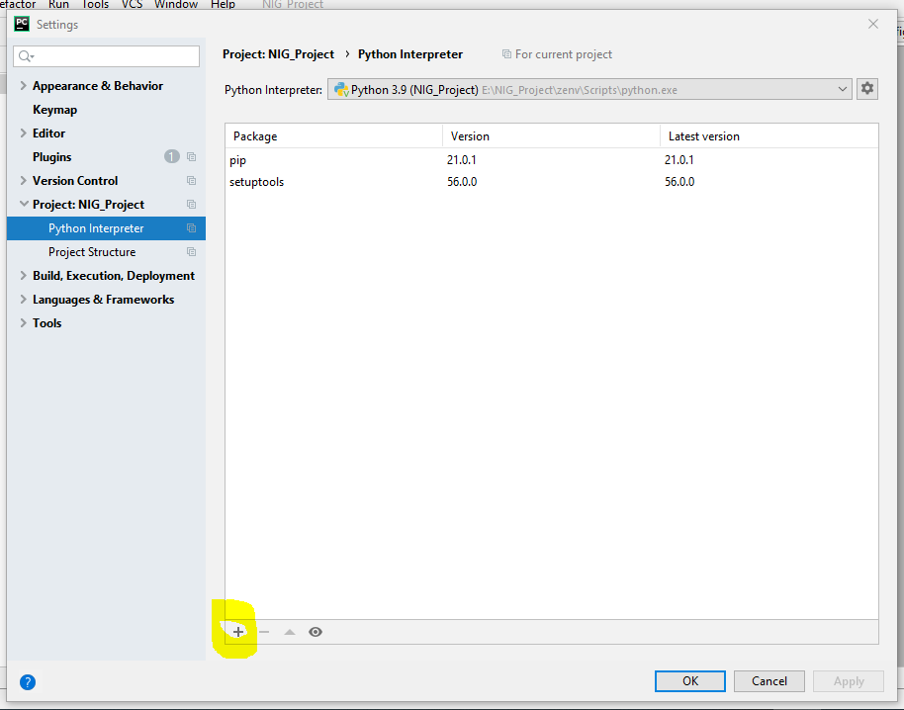In resulted window go to **Project: NIG_Project -> Python Interpreter -> Click on the Plus sign** (Highlighted in the following image).
3. 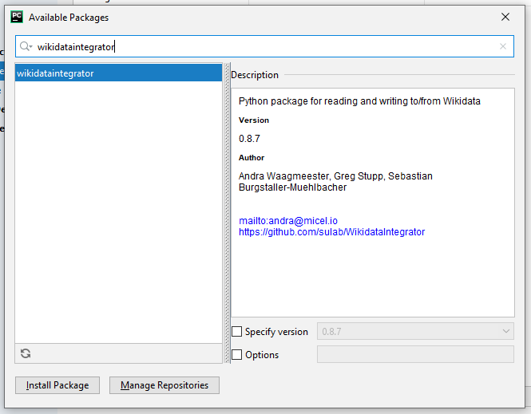In the next window (Available Packages) search for “ ” as follows. It will give the following package as results. Then click on Install Packages.
4. 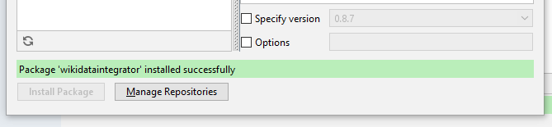After successful installation it will give the following success message. Close the windows (Available Packages and Settings).
5. Search wdi_config.py file. Go to **MainMenu -> Navigate -> Search Everywhere**

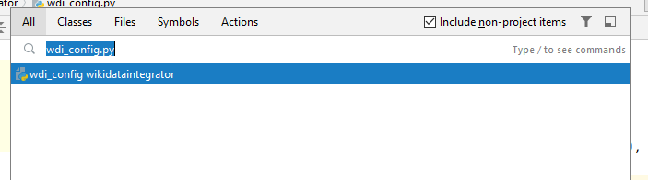In the search window type “wdi_config.py” as follows and open the file.

1. In “wdi_config.py” change the **config** array (in line 21) as follows.

config = {  
 **'BACKOFF_MAX_TRIES'**: **None**,  
 **'BACKOFF_MAX_VALUE'**: 3600,  
 **'USER_AGENT_DEFAULT'**: **'wikidataintegrator/{}'**.format(__version__),  
 **'MAXLAG'**: 5,  
 **'PROPERTY_CONSTRAINT_PID'**: **'P2302'**,  
 **'DISTINCT_VALUES_CONSTRAINT_QID'**: **'Q21502410'**,  
 **'COORDINATE_GLOBE_QID'**: **'http://www.wikidata.org/entity/Q2'**,  
 **'CALENDAR_MODEL_QID'**: **'http://www.wikidata.org/entity/Q1985727'**,  
 **'MEDIAWIKI_API_URL'**: **'http://localhost:8181/w/api.php'**,  
 **'MEDIAWIKI_INDEX_URL'**: **'http://localhost:8181/w/index.php'**,  
 **'SPARQL_ENDPOINT_URL'**: **'http://localhost:8989/bigdata/sparql'**,  
 **'WIKIBASE_URL'**: **'http://wikibase.org'**,  
 **'CONCEPT_BASE_URI'**: **'http://www.wikidata.org/entity/'**}

1. Copy and paste the following project files into the NIG_Project.

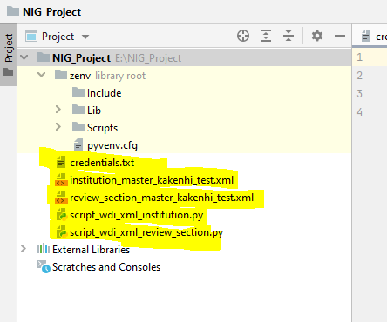

1. 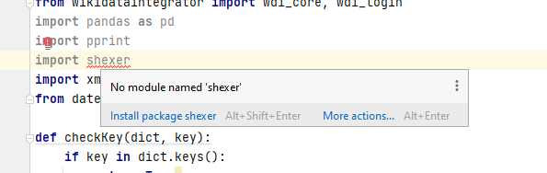Click on the python script file and open it. If a package is not installed will red underlined and showing as follows. If there is an uninstalled package, place the cursor over it. From the popup menu, select Install Package <Package Name>.
2. To run the script open it in the PyCharm editor and place the cursor over the name tab and click right mouse button. It will open the following menu and choose “Run” option from it.

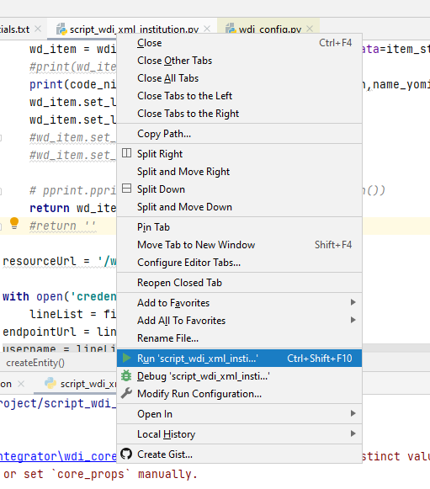

1. To view the changes in the wikibase use following link.

<https://wb.ddbj.nig.ac.jp/wiki/Special:RecentChanges>

**Methods in** [**wikidataintegrator**](https://github.com/SuLab/WikidataIntegrator)

1. **login_instance = wdi_login.WDLogin(user=username, pwd=password, mediawiki_api_url=apiUrl)**

**wdi_login.WDLogin** method is used to login into the Wikibase through an API call.

1. **wd_items = wdi_core.WDItemEngine.execute_sparql_query('SELECT distinct ?item WHERE{ ?item ?label "'+ name_en +'"@en. }')**

**wdi_core.WDItemEngine.execute_sparql_query** method is used to execute a SPARQL query through an API call.

1. **wdi_core.WDCommonsMedia**

**wdi_core.WDExternalID**

**wdi_core.WDForm**

**wdi_core.WDGeoShape**

**wdi_core.WDGlobeCoordinate**

**wdi_core.WDItemID**

**wdi_core.WDLexeme**

**wdi_core.WDMath**

**wdi_core.WDMonolingualText**

**wdi_core.WDMusicalNotation**

**wdi_core.WDProperty**

**wdi_core.WDQuantity**

**wdi_core.WDSense**

**wdi_core.WDString**

**wdi_core.WDTabularData**

**wdi_core.WDTime**

**wdi_core.WDUrl**

The above methods are used to create statements for a particular item.

**Note**: - These methods are explained in a previous document called “Wikidataintegrator data insert samples”

1. **wd_item = wdi_core.WDItemEngine(wd_item_id=qid, data=item_statements)**

**wdi_core.WDItemEngine** method is used to search an item by its QID.

1. **wd_item.write(login_instance)**

**wd_item.write** method is used to write an item to wikidata.

1. **wd_item.get_wd_json_representation()**

**wd_item.get_wd_json_representation** method is used to get JSON representation of an item.